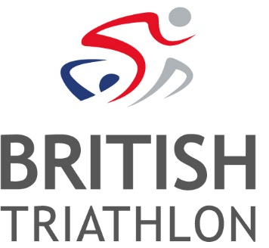
Job Vacancy: East Midlands Regional Academy (EMRA) Head Coach and Loughborough Triathlon Performance Centre (LTPC) Assistant Coach
Ref: PER-17-07
Salary: £18,000-£20,000 (depending on experience) + Benefits + Pension
Contract: FTC (4 Years), Full Time, starting from 1 April 2017

British Triathlon is the National Governing Body for Triathlon, Duathlon and Aquathlon in Great Britain, responsible for raising the profile and delivering medal-winning performances and helping everyone discover, enjoy and achieve in triathlon.
Triathlon England is one of the three Home Nations of British Triathlon, the other two being Triathlon Scotland and Welsh Triathlon. The three Home Nation Associations are responsible for all aspects of triathlon in their respective countries, and contribute to the work of British Triathlon.
British Triathlon are looking to recruit an East Midlands Regional Academy (EMRA) Head Coach and Loughborough Triathlon Performance Centre (LTPC) Assistant Coach to join them from 1 April 2017.
This new role offers an exciting opportunity for the post holder to truly influence the development of future world class triathletes.

Working as the Head Coach for the East Midland Regional Academy the role will entail planning, leading, and delivering on Regional Academy selection and training days, camps, workshops and experiences. The post is vital for the continued development and successful transition of East Midlands’ athletes into Performance Centre environments, which will be seen as one of the key measures of success.

The Loughborough Triathlon Performance Centre (LTPC) Assistant coach role will give the successful applicant the opportunity to learn and develop alongside World Class Programme and University Performance athletes and coaches. The role will play a vital part in ensuring the smooth transition of athletes into LTPC and will be the essential link to the region. The role provides an ideal opportunity for an aspiring Performance Coach.

The role will be based at the Loughborough Triathlon Performance Centre Coaches Office at Loughborough University; however, the nature of the role may require evening and weekend working and occasional travel.
Informal enquiries can be made to Alison Wyeth, email: alisonwyeth@britishtriathlon.org
To apply:
Please visit www.britishtriathlon.org/about/vacancies for our application form, job description and equality form. A covering letter explaining why you feel you are suitable for the role, together with your completed application form and equality form, should be e-mailed to: hr@britishtriathlon.org. Please quote the reference number indicated above. Should you require assistance with the application process, please contact HR and we will make every effort to meet your specific requirements.
Closing Date: 5pm 24th February 2017
Interview Date: 7th March 2017

British Triathlon is committed to equality of opportunity for all staff and applications from all suitably qualified persons are encouraged. Details of our Equal Opportunities Policy can be found on our website: www.britishtriathlon.org under ‘About’ and then ‘Policy Documents’.

