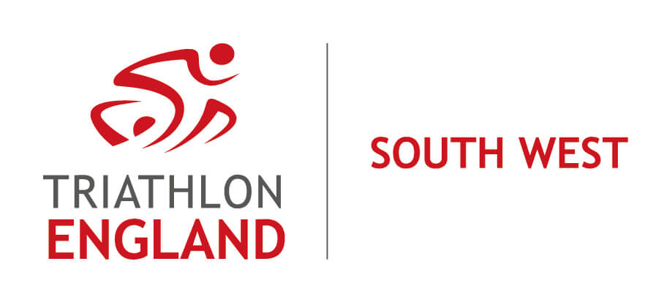

Chair’s Report to 2022 AGM

Welcome to this, the 2022 Triathlon England South West Region Annual General Meeting - the third such meeting being held virtually, due to prevailing circumstances.

I’d like to open by saying thank you to everyone, especially to the many volunteers involved in our sport, in whatever capacity, to the Clubs, the Coaches, the Officials and also to the permanent Triathlon England (TE) staff, who have all helped to return our sport to something like it was before the pandemic. Although as we all know, things have changed.

I am also deeply indebted to my fellow Regional Committee (RC) volunteers. We have continued to meet virtually, and more frequently than pre-pandemic. So still giving the Secretary quite a headache! Thank you to all the Committee members for your perseverance, commitment and support during the past year. And special thanks to Rachel, our Treasurer for the last 5 years - she was first elected at the AGM in 2017 and is not standing for re-election this year.

So, things are not yet quite the same. The range of the Committee during 2022 was greater than last year but not yet as extensive as we’d like. This level of activity is reflected in the incomings and outgoings during the year, which Rachel (the Treasurer) will explain in more detail in her report to the AGM.

We were partially successful in a bid for additional Regional Grant, receiving £1,400 (of the £4,800 applied for), and decided to focus on fostering more diverse participation in the region. Clubs were invited to apply for funding to support local initiatives to promote inclusivity. The Vice Chair and Diversity Co-ordinator, Russ, will say more about how this money will be spent in his report.

Following Triathlon England’s launch of The Big Active, one of its pillars, The Big Intent, that contains five overall objectives, has been interpretated through the creation of Regional Plans, appropriate to specific delivery in each of the ten regions. This through the generation of annual regional objectives to guide the work of Regional Managers and Regional Committees. In the SW we have been busy alongside Debbie, the Regional Development Manager, to meet some of these regional objectives, including working towards the advancement of equality, diversity and inclusivity (EDI), developing the Club Chairs’ Forum and similarly supporting Club Coaches, increasing the number of technical officials (TOs) and improving the Regional Championships. Debbie will tell you more about her particular priorities in the area in her report.

We’ll also hear more about both the work of the TOs this year, and about what it takes to be a TO, from Jon, the Regional Officials Co-ordinator.

The region has again seen activity from our Juniors. A SW squad took part in the Inter-Regional Championships (IRCs) at Sunderland in August. The team enjoyed a good weekend’s racing, although did not make the podium this year. Melanie, the Junior Race Series Officer, will tell us more about the activity of the SW juniors.

Thank you to everyone who took part in a very constructive Club Chairs’ Forum held in July, with the focus on discussion of the future format of the Regional Championships, which looks likely to be Relays. However, the event details are still to be worked out. This will be assisted greatly if we are successful in recruiting to the Senior Race Series Officer vacancy on the Committee.

The South West (SW) is a very varied region, especially in terms of its geography and population distribution. We cover seven counties, from Cornwall to Gloucestershire. Within this area there are 64 clubs affiliated to Triathlon England, together with over 2,000 members.

When I was elected as Chair two years ago, I set out for us to support clubs and members in the region, to secure the financial stability of the Committee, and to raise the profile of the Regional Committee. We have made good progress on these ambitions but there is much still to be done, particularly in procuring continuing resource to sustain swim, bike and run in the region.

Therefore, the SW Committee are looking forward to being even more proactive in serving our sports community in 2023.

So, here’s to a successful 2023 everyone!

