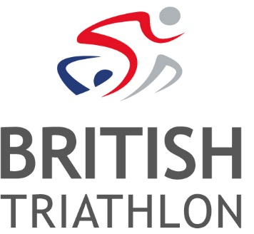
Job Vacancy: British Age-Group Team Coordinator
Ref: OPS-19-1
Salary: Circa £20,000pa + Benefits + Pension
Contract: Open Ended, Full Time

British Triathlon is the National Governing Body for Triathlon, Duathlon and Aquathlon in Great Britain, responsible for raising the profile and delivering medal-winning performances and helping everyone discover, enjoy and achieve in triathlon.
Triathlon England is one of the three Home Nations of British Triathlon, the other two being Triathlon Scotland and Welsh Triathlon. The three Home Nation Associations are responsible for all aspects of triathlon in their respective countries, and contribute to the work of British Triathlon.
British Triathlon is a people centred organisation and aims to deliver great experiences across all our customer profiles. This is an exciting opportunity to be at the centre of the British Age-Group Team development. You will effectively coordinate and administrate the Age-Group Programme and to be the main point of contact for Age Group athletes.
The Great Britain Age-Group Team is the pride of Britain delivering medal-winning performances around the globe year on year. Not only does this role deliver a world-class customer service for British Age-Group athletes, but also offers the opportunity to bring to life the Great Britain Age-Group journey through promotion and communication of the teams racing and successes throughout the season.
The role will be based at the British Triathlon headquarters located at Loughborough University; however, the nature of the role may require evening and weekend working and occasional travel.
Informal enquiries can be made to Linda Haywood, Portfolio Manager, email: lindahaywood@britishtriathlon.org
To apply:
Please visit www.britishtriathlon.org/about/vacancies for our application form, job description and equality form. A covering letter explaining why you feel you are suitable for the role, together with your completed application form and equality form, should be e-mailed to: hr@britishtriathlon.org. Please quote the reference number OPS-19-1. Should you require application forms in an alternative format/language or any adjustments to be made throughout the application process or upon appointment, please contact HR and we will make every effort to meet your specific requirements.
Closing Date: 5pm, Monday 25 February 2019
Interview Date: Thursday 7th March 2019

British Triathlon is committed to equality of opportunity for all staff and is keen to address areas of underrepresentation in its workforce and would particularly welcome applications from all suitably qualified persons from the BAME community, disabled people and people from the LGBT+ Community.
Details of our Equal Opportunities Policy can be found here.

