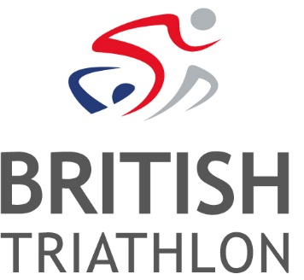
Job Vacancy: Finance Assistant Apprenticeship
Ref: OPS-19-12
Salary: £12,000 to £14,000 + Benefits + Pension
Contract: Fixed term – 2 year 36.25hrs per week including day release

British Triathlon is the National Governing Body for Triathlon, Duathlon and Aquathlon in Great Britain, responsible for raising the profile and delivering medal-winning performances and helping everyone discover, enjoy and achieve in triathlon.
Triathlon England is one of the three Home Nations of British Triathlon, the other two being Triathlon Scotland and Welsh Triathlon. The three Home Nation Associations are responsible for all aspects of triathlon in their respective countries, and contribute to the work of British Triathlon.
BRIEF DETAILS OF THE ROLE:

An initial fixed term apprenticeship of 2 years. The candidate will learn all aspects of the main duties of a finance assistant and study for a recognised accounting qualification ie AAT.
To maintain accurate and comprehensive financial records ensuring the integrity of British Triathlon’s financial reporting.
This includes Purchase Ledger input and control, ensuring Suppliers are paid in a timely fashion, Sales ledger management (invoicing and credit control), Petty cash, banking, and maintaining accurate records.
The role will be based at the British Triathlon headquarters located at Loughborough University; however, the nature of the role may require evening and weekend working and occasional travel.
Informal enquiries can be made to Anne Vinestock (Head of Finance), email: annevinestock@britishtriathlon.org
To apply:
Please visit www.britishtriathlon.org/about/vacancies for our application form, job description and equality form. A covering letter explaining why you feel you are suitable for the role, together with your completed application form and equality form, should be e-mailed to: hr@britishtriathlon.org. Please quote the reference number OPS-19-12. Should you require application forms in an alternative format/language or any adjustments to be made throughout the application process or upon appointment, please contact HR and we will make every effort to meet your specific requirements.
Closing Date: Midday, Wednesday 3rd July
Interview Date: Tuesday 23rd July

British Triathlon is committed to equality of opportunity for all staff and is keen to address areas of underrepresentation in its workforce and would particularly welcome applications from all suitably qualified persons from the BAME community, disabled people and people from the LGBT+ Community.
Details of our Equal Opportunities Policy can be found here.

