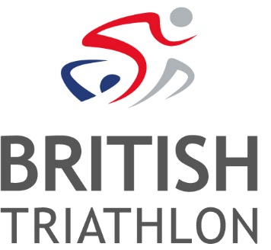
Job Vacancy: Senior Partnerships Executive
Ref: CME-19-3
Salary: £24-28k depending on experience + Benefits + Pension
Contract: Open Ended, Full Time

British Triathlon is the internationally recognised governing body for Triathlon, Duathlon and Aquathlon in the UK.
As a growing sport that is experiencing huge success on the elite international stage, triathlon is becoming an increasingly attractive proposition for brands to engage with in commercial partnerships. As well as laying claim to an excellent collection of existing commercial partners, now is a really exciting time to be a part of the next challenge for British Triathlon’s Commercial department, in maximising the value of these partnerships, as well as attracting even more forward-thinking organisations to partner with the sport.

We are therefore looking to recruit an experienced and skilled Senior Partnerships Executive to join us in the Commercial Partnerships team at an exciting time as we build towards Tokyo 2020. This role will provide high quality account management to a range of key existing and new sponsor accounts, to ensure both the sustainability of those relationships whilst also seeking out new ways to create mutual value.
The role will be based at the British Triathlon headquarters located at Loughborough University; however, the nature of the role may require evening and weekend working and occasional travel.
Informal enquiries can be made to Stuart Searle, email: stuartsearle@britishtriathlon.org
To apply:
Please visit www.britishtriathlon.org/about/vacancies for our application form, job description and equality form. A covering letter explaining why you feel you are suitable for the role, together with your completed application form and equality form, should be e-mailed to: hr@britishtriathlon.org. Please quote the reference number CME-19-3. Should you require application forms in an alternative format/language or any adjustments to be made throughout the application process or upon appointment, please contact HR and we will make every effort to meet your specific requirements.
Closing Date: 5pm - Wednesday 20th March 2019
Interview Date: Monday 25th & Tuesday 26th March 2019

British Triathlon is committed to equality of opportunity for all staff and is keen to address areas of underrepresentation in its workforce and would particularly welcome applications from all suitably qualified persons from the BAME community, disabled people and people from the LGBT+ Community.
Details of our Equal Opportunities Policy can be found here.

