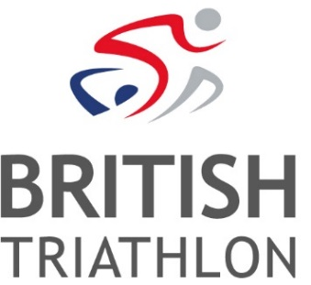
JOB DESCRIPTION

TITLE: | Senior Partnerships Executive
CONTRACT TYPE: | Open Ended, Full Time
ORGANISATION: | British Triathlon
DEPARTMENT: | Commercial and Major Events
JOB BASED AT: | British Triathlon Headquarters, Loughborough
REPORTS TO: | Commercial Partnership Manager

POSITION OVERVIEW
This role will account manage a selection of British Triathlon’s relationships with commercial partners and suppliers, delivering on agreed rights, rewarding activation campaigns and driving value for the sport and brands that we work with.
MAIN TASKS & RESPONSIBILITIES
- Account management of a selection of British Triathlon’s commercial partners
- Support the Commercial Partnership Manager and Director, Commercial & Major Events in the smooth day to day operations of the Commercial & Major Events department
- Add value to commercial partnerships and the sport by fostering a culture of collaboration and cooperation amongst internal and external stakeholders
- Represent commercial team and partners at major event LOC (local organising committee) meetings, executing strategies and activation campaigns
- Drive brand led content production and distribution with communications team, supported by commercial partners
- Actively contribute to the achievement of British Triathlon and Triathlon England’s strategic goals, including driving revenue from commercial sources
- Support in the delivery of internal communication messages ensuring staff are informed and engaged in relevant partnerships, events and activations
- Support the Marketing & Communications team in the development and delivery of Major Events marketing and communications plans
- Promote a positive image of triathlon in all dealings with internal and external contacts
- Contribute to and attend external events, which may include weekend and unsocial working hours as required to deliver the role

PERSON SPECIFICATION
SENIOR PARTNERSHIPS EXECUTIVE
RELEVANT SKILLS AND/OR APTITUDES
Essential
- Strong mindset of adding value to partnerships by developing robust and comprehensive campaigns
- Develop and maintain excellent relationships with external and internal stakeholders
- Ability to positively influence and advocate ideas, campaigns and policies
- Creative and innovative approach to partnerships which standout in the sector
- Strong and confident communicator in written, verbal and electronic forms
- Excellent command of written English with copy accuracy
- Excellent quality control and attention to detail

KNOWLEDGE AND EXPERIENCE
Essential
- Track record of managing partnerships with brands as a rights holder, agency or in-house as a sponsor
- Demonstrable experience of a client focused role ideally within sport/culture/arts or similar
- Understanding of the sports landscape, NGBs, sponsors, media, participants, fans
- Knowledge of all major Microsoft packages
- Strong written and verbal presentation skills
- Strongly partner-focused and aware of their needs and expectations
Desirable
- Passion for sport and triathlon
- Experience at major events

EDUCATION/QUALIFICATION SKILLS
Essential
- Educated to degree level in a relevant discipline or educated to A Level or with equivalent industry experience
- Computer literate, including Office products
- Strong written and oral presentation skills
PERSONAL ATTRIBUTES
Essential
- Passionate, enthusiastic and positive
- Work with honesty and integrity, treating people with respect
- Creative & innovative worker
- Focused on excellent quality of service
- Able to work independently and as part of a team
- Able to effectively deliver multiple activities and relationships at any given time
- Organised and able to prioritise workload under pressure and with tight deadlines
- Exceptional interpersonal skills
- Excellent attention to detail

OTHER REQUIREMENTS
Essential
- Able to work away from home as role may require occasional weekend working and irregular hours

