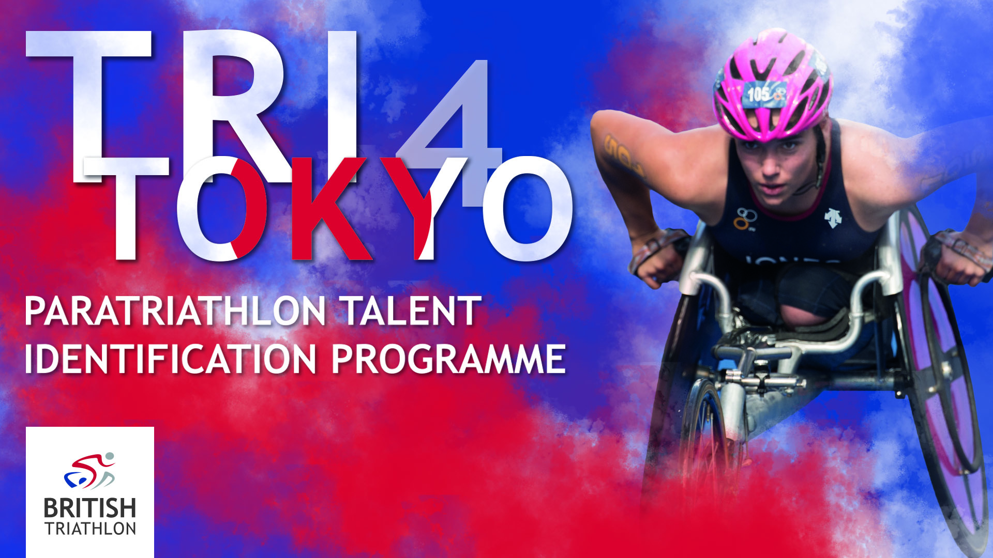

APPLICATION FORM

Name:

Age: DOB:

Address:

Email: Tel:

Next of kin:

Relationship: Contact number:

Please list sports competed in and achievements in each:

Please note any other sports classifications you hold:

Typical number of hours trained per week:

Please explain why you want to attend this Talent Identification event:

Details of Impairment
Impairment Type:
Part(s) of body affected:
Acquired or congenital:
If acquired, which year:

Please provide your best times for the disciplines of a Sprint Distance Triathlon, where known:

750m Swim

20km Bike

5000m Run

This is a practical two day event and you will be required to take part in all three disciplines across both days, therefore please consider whether there is any support we could provide that would be useful to you.

Would you require support whilst on this camp?

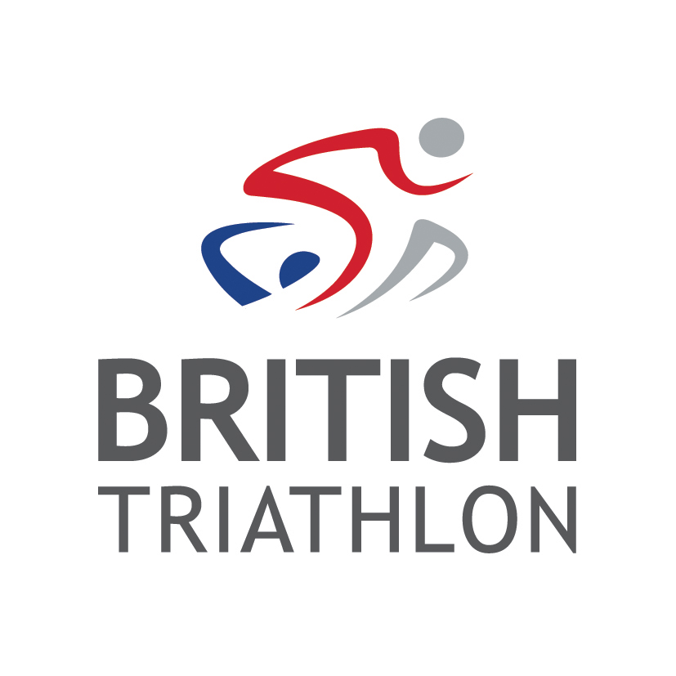
Any other medical conditions we should be aware of?

Where did you hear about this event?

Applications in by Monday 16th April 2018

