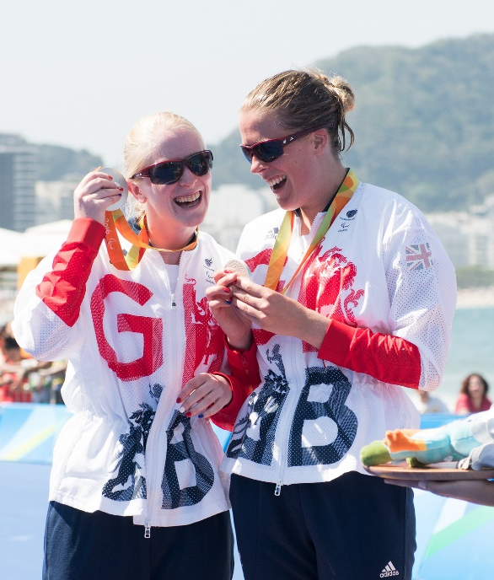
Guides for Gold: Tokyo

Personal Details
Name: DOB:

Address:

Email:

Phone:

Sporting Information
Results
Please note your most significant results as a triathlete.

Personal Bests
Please indicate your best times for each discipline, to include performances both within triathlon and as single discipline races/time trials. Please also indicate any other times here you believe would support your application.
Swimming: 400m pool swim:
750 open water:
1500m open water:

Cycling: 10mile TT:
25mile TT:
20km:
40km:
Power Output tests:

Running: 5km:
10km:

Personal Goals in Triathlon

Further Information
Why are you applying for this programme?

Are you applying for the race guide or training guide role, or both?

What is your current coaching set up?

Where is your primary training base?

When did you last compete in an ITU race?

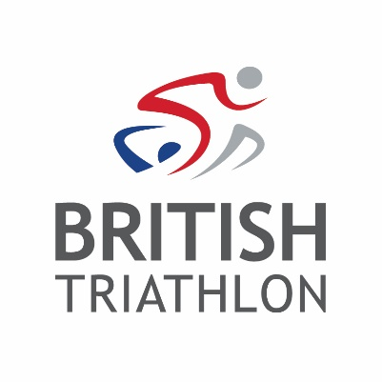
Next of Kin
Name: Relationship:

Phone 1: Phone 2:

Email:

