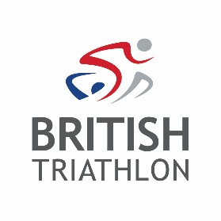
Officials Checklist

To be completed two weeks before the event. Please remember your insurance only covers you to officiate at permitted events.

You should contact the race organiser to check: | Tick | Comments | Action: By Whom?
The event is registered with British Triathlon and the Event Permit has been received. If you are unsure about an events permitting status, please call 01509 226162/226186 or email events@britishtriathlon.org
What time you are required to arrive on race day
What time the event briefing will be held
How to get to the venue and where to park
How you will communicate with the Event Organiser at the event
Expected number and ability of competitors
The number of waves, time of waves and number of competitors in each
That notice boards will be available to post results and penalties
What expenses you will receive and whether you will be provided with refreshments
What first-aid cover will be present at the event

