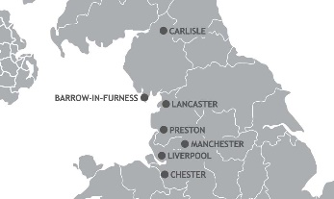 Triathlon England Junior series 2020

2020 series report
The 2020 junior series we had planned had numerous changes from previous years with reduced number of events in the series to promote better quality events and get more athletes taking part and to safe guard the athletes in over racing. Triathlon England had encouraged more Aquathlon’s to try and improve swim standards in all age groups from grass roots to professionals.
We had also planned training days for the athletes to learn new skills open to all, a magic weekend at Chomlondley castle triathlon and with the re-introduction for 2020 of the adult series and linking the 17-19 year olds with some adult events should have been a new direction for the series to take.( Regarding moving the 17-19 year olds to adult events we did not quite get this right and listened to feedback and will try and amend for 2021).
2020 started with the 2019 award evening at Preston. In January 2020 with 150 attendees on the night , the event was not perfect but everyone had a good time. I have still have numerous trophies still to be issued.
This was followed by our first event the Wirral Aquathlon in early March. A good turnout at the Wirral (thanks to Mersey tri for organising as ever) in bad weather conditions and our season was off and running with good performances.
Mid-March the country was locked down with Covid virus. With no signs of improvement over many weeks we heavy heartedly decided under guidance to cancel the whole season with everyone’s safety our primary concern and not knowing when or if we could continue. Many thanks to the clubs who were organising the event so for 2020.
Thanks to all the clubs and event organisers who promoted and ran virtual events for our athletes to train and complete in over the lock down months and to keep them involved and focused in these tough times.
2021 series
We will start planning the 2021 series after the AGM but intend hopefully to have a complete series. It may take a different form due to restrictions but we hope to run a Junior and senior series next year.
Aims for 2021 -
Better events for athletes to take part in.
Encourage more participation from first timers to experienced athletes in all age groups. Especially 16-19 year olds as numbers drop in this age group. This was why we tried to merged this age group with adult events to offer a stepping stone for these athlete’s before racing adult events.( were looking at this again)
Get more athletes to join clubs and possibly TE or home nations.
Re introduce the club championships for juniors and the seniors.
Have the NW a great region to compete in with opportunity for all at any age or standard.
The new committee formed last year are more focused to deliver our plans and ideas and give opportunity to all to compete in events, learn new skills and make new friends.
Paul Ekgren
Junior series coordinator.

