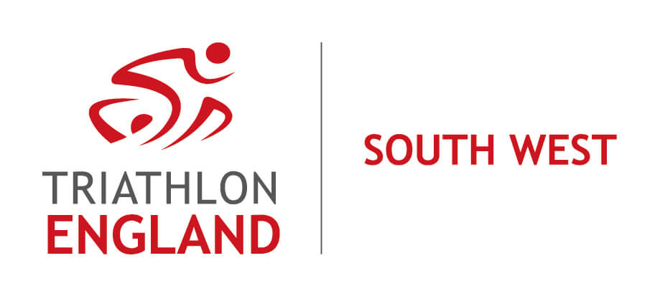

Chair’s Report to 2021 AGM

Welcome to this, the 2021 Triathlon England South West Region Annual General Meeting - the second such meeting being held virtually, due to prevailing circumstances.

Well, what a year it has been! The global pandemic overshadowed every aspect of all of our lives, including our sporting life. In and out of lockdown in 2021, with training venues closed and races cancelled, we just did what we could, when we could, within ever changing guidelines. As you know, triathletes are determined folk, and so we have made it through. Thank you to everyone, especially to the many volunteers involved in our sport in whatever capacity, to the Clubs, the Coaches, the Officials and also to the permanent Triathlon England (TE) staff.

I am deeply indebted to my fellow Regional Committee (RC) volunteers. Although, like everyone else, we haven’t been able to get together face-to-face, we have met virtually, and more frequently than ever before. Quite a headache for the Secretary! Thank you to all the Committee members for your perseverance, commitment and support during the past year.

The Committee’s approach in encouraging the return to sport, after living with many restrictions, including reduced training and racing opportunities, has been to focus on participation rather than competition. And so it was in our decision not to hold a Regional Championship this year, and instead to publicise the events that were available in the region through our regular Face Book posts, augmented by Russ and Jon. The Summer racing post in July successfully reached 1145 and engaged 508, boosted by paid advertising with Face Book throughout a 10-day period, at a cost of only £25. This spend represented value for money compared with the reach and engagement of other similar posts.

The range of the Committee during 2021 was, like everything else, rather limited, which was frustrating. This reduced level of activity is reflected in the incomings and outgoings during the year, which Rachel, the Treasurer will explain in detail in her report to the AGM.

However, we have established a Club Chairs’ Forum that has met twice already and will meet approximately quarterly in future. This is a great way for clubs to interact and share good practice over issues of mutual interest. The Committee are also looking to review the future format of the Regional Championships. This review would be greatly helped if we could fill the vacancy on the Committee for a Senior Race Series Officer. We also need to recruit a Communications & Social Media Co-ordinator. Is anyone interested? Expressions of interest are very welcome.

The South West (SW) is a very varied region, especially in terms of its geography and population distribution. We cover seven counties, from Cornwall to Gloucestershire. Within this area there are 62 clubs affiliated to Triathlon England, together with 2,693 members. You’ll hear more about these aspects of the region from Debbie, the Regional Manager.

Our region has a team of 42 Technical Officials (TOs), qualified at four different levels, including current trainees. During the 2021 season there were 64 events permitted by British Triathlon held across the region. A huge shoutout goes to the Events Organisers who arranged Covid-safe race opportunities in the SW for our competition-starved athletes. You’ll hear more about what it takes to be a TO from Jon, the Regional Officials Co-ordinator.

The region has once again seen success for our Juniors. A SW squad took part in the Inter-Regional Championships (IRCs) at Mallory Park in September, and they took Bronze on the podium. Well done! The Committee were pleased to be able to contribute towards the cost of team kit, and also to be involved in confirming the selection of the IRC squad. Melanie, the Junior Race Series Officer, will tell us more about the junior team and their activities.

Along with everyone on this call, the SW Committee look forward to being more active in 2022, and more proactive in serving our SW sports community 2022. When I was elected as Chair last year, I set out for us to support clubs and members in the region, to secure the financial stability of the Committee, and to raise the profile of the Regional Committee. We have made a start on these ambitions but there is much more to be done. So, here’s to a successful 2022.

