Appendix 3: Nomination Form for Election of Committee Members
TRIATHLON ENGLAND REGIONAL COMMITTEE ELECTION PRO FORMA
South West Region
Committee Vacancy: Junior Race Series Officer

Full name of Nominee: Melanie Cumberland
Place of residence (Town): East Challow, Wantage
Triathlon England Membership No: E1043788
Club (if applicable): Vale Tridents Junior Triathlon Club
Date of Birth (if under 18):

Full name of Proposer: Rachel Hepworth
Triathlon England Membership No: E1052647
Club (if applicable): n/a

Full name of Seconder: Alan Bayliss
Triathlon England Membership No: E1052869
Club (if applicable): Salisbury Tri Club

Proposer supporting statement (max 200 words):
Melanie has shown incredible commitment to junior development in the south west and support to the IRC Team and junior series. I have no hesitation in proposing her for the role of Junior Race Series Officer.

Nominee supporting statement (max 200 words):
I am happy to continue organising the SWS for BTF and managing the IRC Team selected from the results of the SWS. This is a role I have undertaken since 2015.

Declarations:
If elected to the South West Regional Committee, I, the aforementioned nominee, agree to abide by:
- The Triathlon England Conflicts of Interest Policy
- The Triathlon England Code of Conduct
In submitting this nomination, we provide our consent for the information contained within this form to be shared with Triathlon England South West Members via the means prescribed by the South West Regional Committee.

Nominee: MJCumberland
Date: 29 Sep 21

Proposer: Rachel Hepworth
Date: 29th Sept 2021

Seconder: 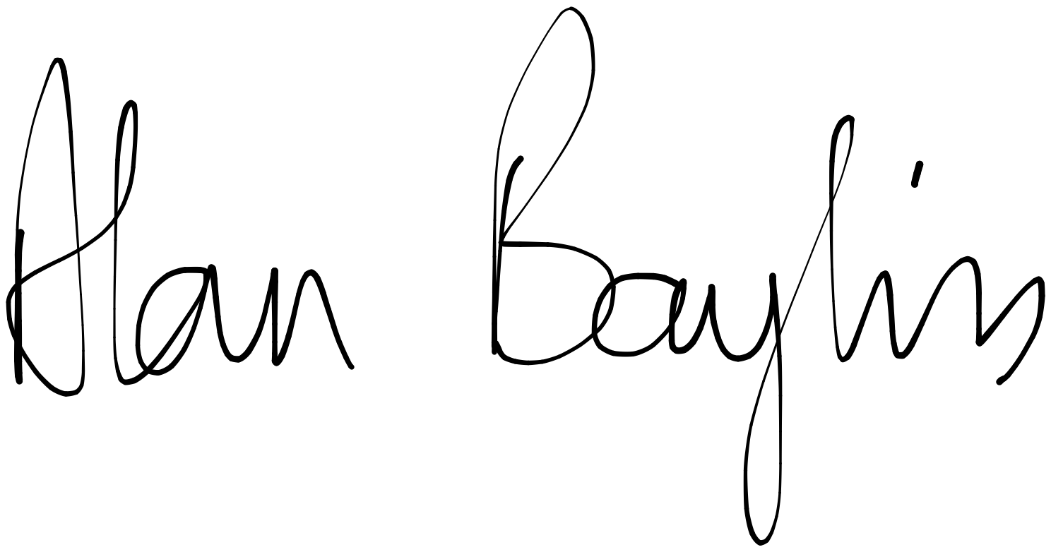

Date: 1st October 2021

