Appendix 3: Nomination Form for Election of Committee Members
TRIATHLON ENGLAND REGIONAL COMMITTEE ELECTION PRO FORMA
South West Region
Committee Vacancy: Regional Officials Co-ordinator

Full name of Nominee: Jon Shaw
Place of residence (Town): Cherhill, Wiltshire
Triathlon England Membership No: E10108042
Club (if applicable): N/A
Date of Birth (if under 18):

Full name of Proposer: Alan Bayliss
Triathlon England Membership No: E1052869
Club (if applicable): Salisbury Tri Club
Aln Bayliss

Full name of Seconder: Jane Wild
Triathlon England Membership No: E126768
Club (if applicable): Cheltenham Triathlon Club

Proposer supporting statement (max 200 words):
I have known Jon for a few years now as I first shadowed him whilst doing my LTO training, and have worked with him over the last year after he was co-opted onto the committee to fill the Regional Officials role. In that time, he has completely changed the way officials communicate in the region, including setting up WhatsApp and Facebook Groups for communication and knowledge sharing, bringing a greater sense and spirit of unity to the SW TOs. I have no hesitation in nominating him to continue with the great work he has already started.

Nominee supporting statement (max 200 words):
My involvement within the world of Triathlon dates back a number of years now, starting as Water Crew and later switching to the role of the Technical Official, an appointment for which I have a genuine passion for. I’m especially interested in grass root events as they allow me to be fully immersed providing support, advice, guidance and encouragement to a diverse group of competitors and the event organisers.
I volunteered for the role of Regional Officials Coordinator for the 2021 season and I would be more than happy to continue the role for the 2022 and 2023 season.
I believe that I have more to contribute providing support, advice and guidance, at a technical level, to our regional TO’s and Event Organisers at all levels, to encourage and secure the success of Triathlon events within the South West region.

Declarations:
If elected to the South West Regional Committee, I, the aforementioned nominee, agree to abide by:
- The Triathlon England Conflicts of Interest Policy
- The Triathlon England Code of Conduct
In submitting this nomination, we provide our consent for the information contained within this form to be shared with Triathlon England South West Members via the means prescribed by the South West Regional Committee.

Nominee: Jonathan Shaw
Signed: J Shaw
Date: 15th September 2021

Proposer: Alan Bayliss
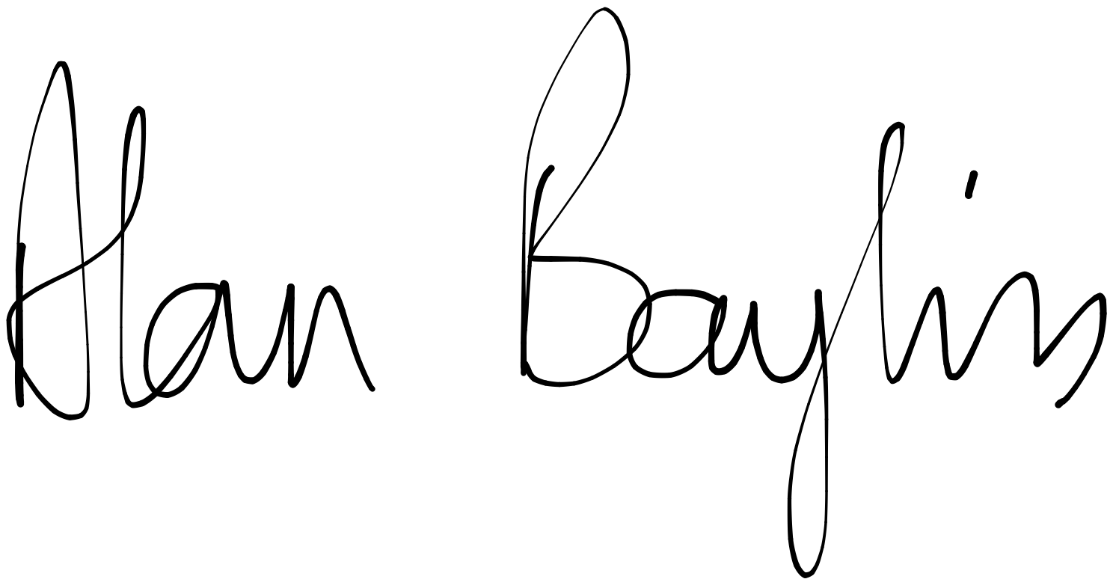
Date: 29th September 2021

Seconder:
Date:
30 September 2021

