Nomination Form for Election of Committee Members
TRIATHLON ENGLAND REGIONAL COMMITTEE ELECTION PRO FORMA
South West
Committee Vacancy: Regional Committee Secretary
Full name of Nominee: Alan Bayliss
Place of residence (Town): Salisbury
Triathlon England Membership No: E1052869
Club (if applicable): Salisbury Tri Club
Date of Birth (if under 18):

Full name of Proposer: Jane Wild
Triathlon England Membership No: E126768
Club (if applicable): Cheltenham Triathlon Club

Full name of Seconder: Jon Shaw
Triathlon England Membership No: E10108042
Club (if applicable): N/A

Proposer supporting statement (max 200 words):
I’ve known Alan for five years now, since he took over from me as TE SW Regional Committee Secretary back in October 2017. Thus, we have worked on the Committee together for a long while. In this context he is an esteemed colleague, contributing valuably to the work of the Committee.
Alan fulfils his role as Secretary satisfactorily, arranging and giving notice of Regional Committee meetings, together with circulating an appropriate agenda. He records the proceedings of all such meetings and documents them later as Minutes made available to members of the Committee.
Alan is himself an active triathlete, competing in many national international, championship and other challenging races. He is a member of Salisbury Tri Club, where he both trains and coaches, and where he is currently Club Chair. He is also a qualified Technical Official.
I therefore propose that Alan be re-elected as Regional Committee Secretary for a further two-year term of office.

Declarations:
Nominee supporting statement (max 200 words):
I have been the South West Regional Committee Secretary for the last four years and am happy to continue in the position to help develop and promote triathlon and multisport in our region going forward.

If elected to the South West Regional Committee, I, the aforementioned nominee, agree to abide by:
- The Triathlon England Conflicts of Interest Policy
- The Triathlon England Code of Conduct
In submitting this nomination, we provide our consent for the information contained within this form to be shared with Triathlon England South West Members via the means prescribed by the South West Regional Committee.

Nominee: Alan Bayliss
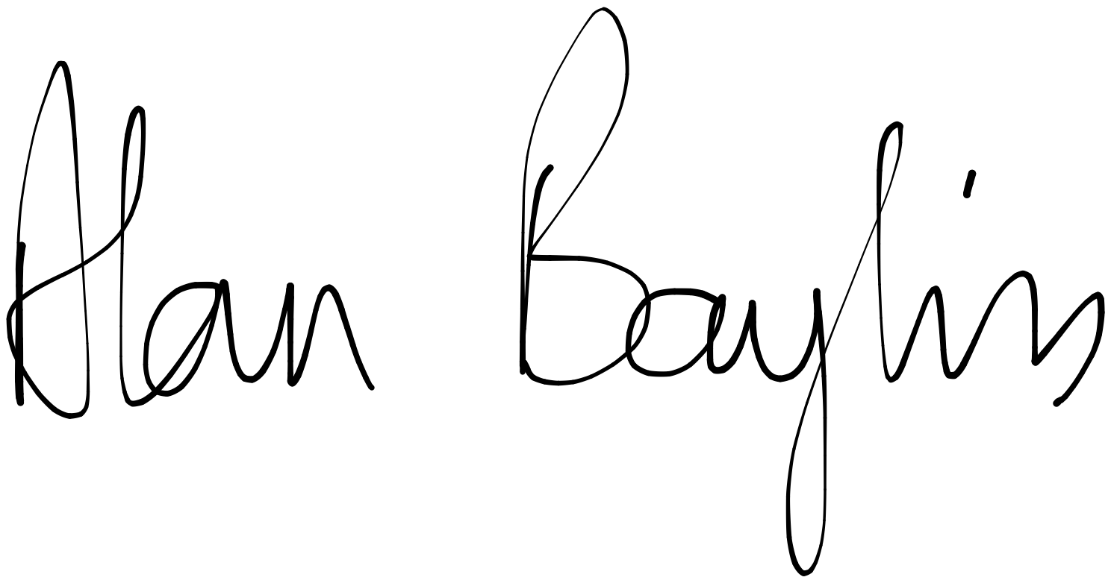
Date: 1st October 2022

Proposer: Jane Wild
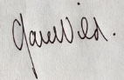
Date: 3 October 2022

Seconder: Jon Shaw
Date: 3 October 2022

