Appendix 3: Nomination Form for Election of Committee Members
TRIATHLON ENGLAND REGIONAL COMMITTEE ELECTION PRO FORMA
South West Region
Committee Vacancy: Communications & Social Media Co-ordinator

Full name of Nominee: Toby Levy
Place of residence (Town): Calne
Triathlon England Membership No: E1087687

Club (if applicable):
Date of Birth (if under 18):

Full name of Proposer: Alan Bayliss
Triathlon England Membership No: E1052869
Club (if applicable): Salisbury Tri Club

Full name of Seconder: Jane Wild
Triathlon England Membership No: E126768
Club (if applicable): Cheltenham Triathlon Club

Proposer supporting statement (max 200 words):
Having got to know Toby and seen the great work he has done for us on the social media front since he was co-opted onto the committee, I’m more than happy to propose him as our official Social Media Officer.

Nominee supporting statement (max 200 words):
Having been co-opted into this role for a few months, I’d like to renew my intentions to be approved for the role at the AGM.

As someone who works in marketing specifically in content and social media, I believe I am well suited to provide assistance to the region for this role.

I have previously outlined to the committee my intentions for how to streamline the process of gathering regional news and spreading it from the South West pages, however this is yet to become adopted by most of the clubs or events in the region.

My experience within events and in an organisational, timing and official capacity give me an insight and reach, but also keeps my interests in the growth of the sport in general.

I would love to continue building on what I’ve started, hopefully with continued support from more and more clubs adopting my new simplified system.

Declarations:
If elected to the South West Regional Committee, I, the aforementioned nominee, agree to abide by:
- The Triathlon England Conflicts of Interest Policy
- The Triathlon England Code of Conduct
In submitting this nomination, we provide our consent for the information contained within this form to be shared with Triathlon England South West Members via the means prescribed by the South West Regional Committee.

Nominee: Toby Levy
Date: 30 September 2022

Proposer: Alan Bayliss
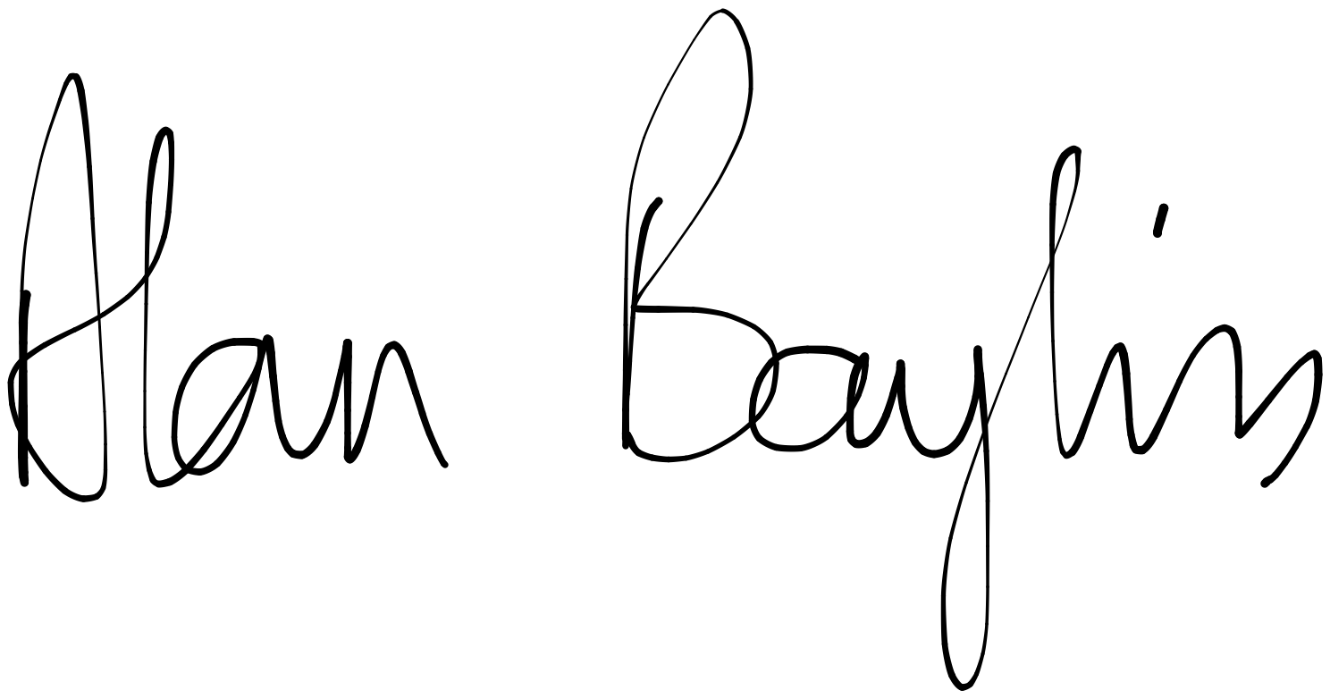
Date: 1st October 2022

Seconder: Jane Wild
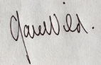
Date: 1 October 2022

