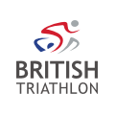
Kirsty Outhwaite
Regional Manager: West Midlands
West Mids, Staffordshire, Shropshire, Warwickshire, Worcestershire, Herefordshire
AGM Report for 6th November 2023, West Midlands
The work programme of the Regional Managers is based around the values and goals laid out in the British Triathlon Strategic plan: 2019-2024.
Our 4 Values:
- We are people centred
- We are ambitious
- We are inclusive
- We do what’s right

Our Goals:
- More Participants
- Great Clubs
- Growing Membership
- Winning athletes

Our enabling goals:
- Exceptional People
- Outstanding events
- Excellent Organisation
- Elevated Profile

The Big Active

Launched by Triathlon England in September 2021 for the next 10 years. This is a big focus for the Regional Managers. Triathlon England want to focus more on why people take part in our sport, how it shapes, adds value and truly changes lives. Click here to find out more.
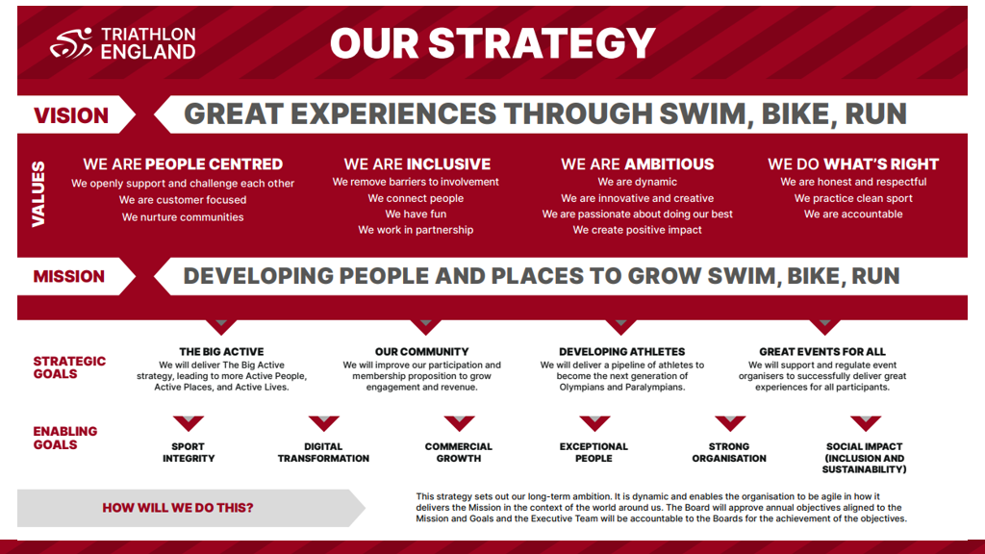
Following the 5 big intents: A richer and more diverse profile of participants and people, Priority places that swim bike run, A strong core from which to build and grow, A broader framework of opportunities, and People who thrive; for themselves and for the sport.

This is still very much the approach and we continue to empower communities to live better and healthier lives whilst still developing our sport for all new and existing customers.

Priority Places

There are 18 Priority Places for Triathlon England across England. These priority places have been selected for focused community development due to a number of factors: Level of deprivation, assets such as green and blue spaces, Triathlon support locally in the form of a club, opportunities and support from local partners to name a few.

Within the West Midlands, we still have 3 main wards – Birchills Leamore, Bisley and West Bromwich. Although in within Sandwell, I have ventured out to the next door towns of West Brom and started development work in Smethwick and Cradley Heath.

Courses

Swim Bike Run leader award with Safeguarding and Protecting Children course

This course is online with the following dates and times.

- Wed 22nd November 6.30pm to 8.30pm
- Thurs 23rd November 6.30pm to 8.30pm
- Thurs 30th November 6.30pm to 9.30pm
Only £15 per person as we are giving a 75% bursary for all West Midlands members.
Please click here to first of all fill out the bursary form.
You will then receive a code to book on the course through your Triathlon England membership.
With this course, it would be brilliant for those who want to broaden their experience of becoming a leader, to use your skills and learn more by outing on some Swim bike run explore sessions. Please read below further to our SBR programmes.
Foundation Course
16th November – 20th January 2024
Group Course
17th January – 24th February 2024
CPD courses
Please click here. We have many courses coming up so please take a look through and share with your members. We have the following,
- SBR Leader awards
- Club coach leadership 10.2 and 10.3
- Safeguarding and protecting children
- Including disabled people in triathlon
- Coaching children and young people

The new replaced GO TRI

For those looking to build their confidence, to anyone seeking local and regular exercise, Swim Bike Run has something for everyone. Whether it's learning new bike skills, swimming in open water or exploring your local area, check out what Swim Bike Run has to offer here. There are 5 programmes to suit your needs for all coaches and clubs/communities.

Please see below table for the West Midlands targets – This gives you a good idea of how many events and sessions we would like in the region. I do need your help if this is something you would like to try within your clubs or as new coaches/leaders.

Regional Objective | Target Figure (If Relevant)
5 SBR Develop OW one off session | 5
1 SBR Develop Bike Skills one off sesison | 1
5 SBR Develop - Intro to Tri one off session | 5
1 SBR Develop OW 6 weeks course | 1
1 SBR Develop Bike Skills 6 weeks course | 1
1 SBR Develop - Intro to Tri 6 weeks course | 1
1 SBR Develop Pool 6 weeks course | 1
1 SBR Develop run 6 weeks course | 1
3 SBR Explore OW-Dip sessions | 3
5 SBR Explore Bike sessions | 5
3 SBR Explore Run sessions | 3
4 SBR Family Mini events | 2
4 SBR Kids Mini events | 2
4 SBR Adult Mini events | 2
3 SBR Local events | 3

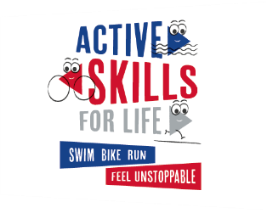

Giving every child the confidence to experience swim, bike, run Active Skills for Life uses swim, bike, run to combine playing and learning to teach children aged 7-14 essential skills that can be used in all aspects of life. Active Skills for Life resources offer a unique blend of playfulness and educational depth. The resources are carefully crafted to complement the National Curriculum, making it easier for educators to seamlessly integrate active play into their teaching plans. Please click here to find out more and how you can engage to help your clubs/communities. By signing up to the engage package, its free and you get access to tools straight away with session cards. This is a great way to help support junior clubs and to start new ones if this is something you would like to support.

For any programmes we offer, please let me know if you are interested and would like a further chat.

If you have any questions or queries before the AGM, please don’t hesitate to contact me either by email or phone.
kirstyouthwaite@triathlonengland.org
07739526556
Kind Regards
Kirsty Outhwaite – West Midlands Regional Manger

