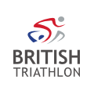
Kirsty Outhwaite
Regional Manager: West Midlands
West Mids, Staffordshire, Shropshire, Warwickshire, Worcestershire, Herefordshire
AGM Report for 17th October 2022, West Midlands
The work programme of the Regional Managers is based around the values and goals laid out in the British Triathlon Strategic plan: 2019-2024.
Our 4 Values:
- We are people centred
- We are ambitious
- We are inclusive
- We do what’s right

Our Goals:
- More Participants
- Great Clubs
- Growing Membership
- Winning athletes

Our enabling goals:
- Exceptional People
- Outstanding events
- Excellent Organisation
- Elevated Profile

The Big Active

Launched by Triathlon England in September 2021 for the next 10 years. This is a big focus for the Regional Managers. Triathlon England want to focus more on why people take part in our sport, how it shapes, adds value and truly changes lives. Click here to find out more.
Following the 5 big intents: A richer and more diverse profile of participants and people, Priority places that swim bike run, A strong core from which to build and grow, A broader framework of opportunities, and People who thrive; for themselves and for the sport.

Regional Plans

This will be a focus for my work, the regional committee’s work and our partners in the region. It covers how we intend to get more people doing swim bike run through focused community work, more and stronger clubs, more events catering for all levels of participants and a more rounded children’s offer. How we intend to support and grow our clubs, offering more opportunities through events. How we grow our coaches, activators, leaders and officials through courses, continued personal development and mentoring. This is just the first year on the journey and there is much to do and exciting times ahead.

Priority Places

There are 18 Priority Places for Triathlon England across England. These priority places have been selected for focused community development due to a number of factors: Level of deprivation, assets such as green and blue spaces, Triathlon support locally in the form of a club, opportunities and support from local partners to name a few.

Within the West Midlands, we have 2 main wards – Birchills Leamore and West Bromwich.

In Birchills Leamore, I’m supporting the Son of Rest Community Centre in getting cycling embedded within the community. After 18 months of building a relationship within the ward and asking what is needed, it’s clear there is a real passion for learning to ride. We have now teamed up with Cycling UK, One Walsall and Cycle Confidence to secure cycle rides every Saturday in Reedswood Park with over 55 people taking part of all ages for all families. The centre now also have bike storage to fit the 50 bikes they have built up over the last year. Next steps will be to upskill 3 of the interested volunteers (once they can ride) to lead the rides rather than paying for cycle leaders, this will be the start of embedding for long term sustainability.

In West Bromwich, we now have a new role filled – Francesca Coakley who is the Community Coordinator for the ward. Francesca will be continuing to build the legacy off the back of the Commonwealth Games, working with the local communities embedding Swim, Bike and Run. Francesca is partnering up with British Cycling’s Activator within West Brom as well as Swim England’s project manager. Further chats are being had with the Sandwell Legacy manager on how to support with the exciting work to come and how this will fit in with the new aquatic centre for August 2023.

Coaching Bursaries

Current and aspiring swim, bike, run leaders and coaches in the West Midlands region can now apply for a bursary to further their development as the region celebrates hosting the Commonwealth Games this summer.
The launch of the bursary coincides with the triathlon and para triathlon events being held at Birmingham 2022 with Triathlon England wanting to use the Games to inspire more people to take up leading and coaching to provide more opportunities for local people to get involved in swim, bike, run.
Through the bursaries, successful applicants will receive up to 75 per cent off the cost of completing their activator or coaching course with 100 bursaries on offer to people living and delivering swim, bike, run activity in the West Midlands region.
Wave 1 has already seen 21 applications with 18 successful applicants. Wave 2 is out now and we want a big focus on upskilling anyone who wishes to take the Activator course and young activators course. If there is any other courses that you wish to apply for through this, then please don’t hesitate to contact me. Please fill out the application form before the 7th November here.

The total of Clubs, Coaches, Activators, Events and TE Members – 2021-22

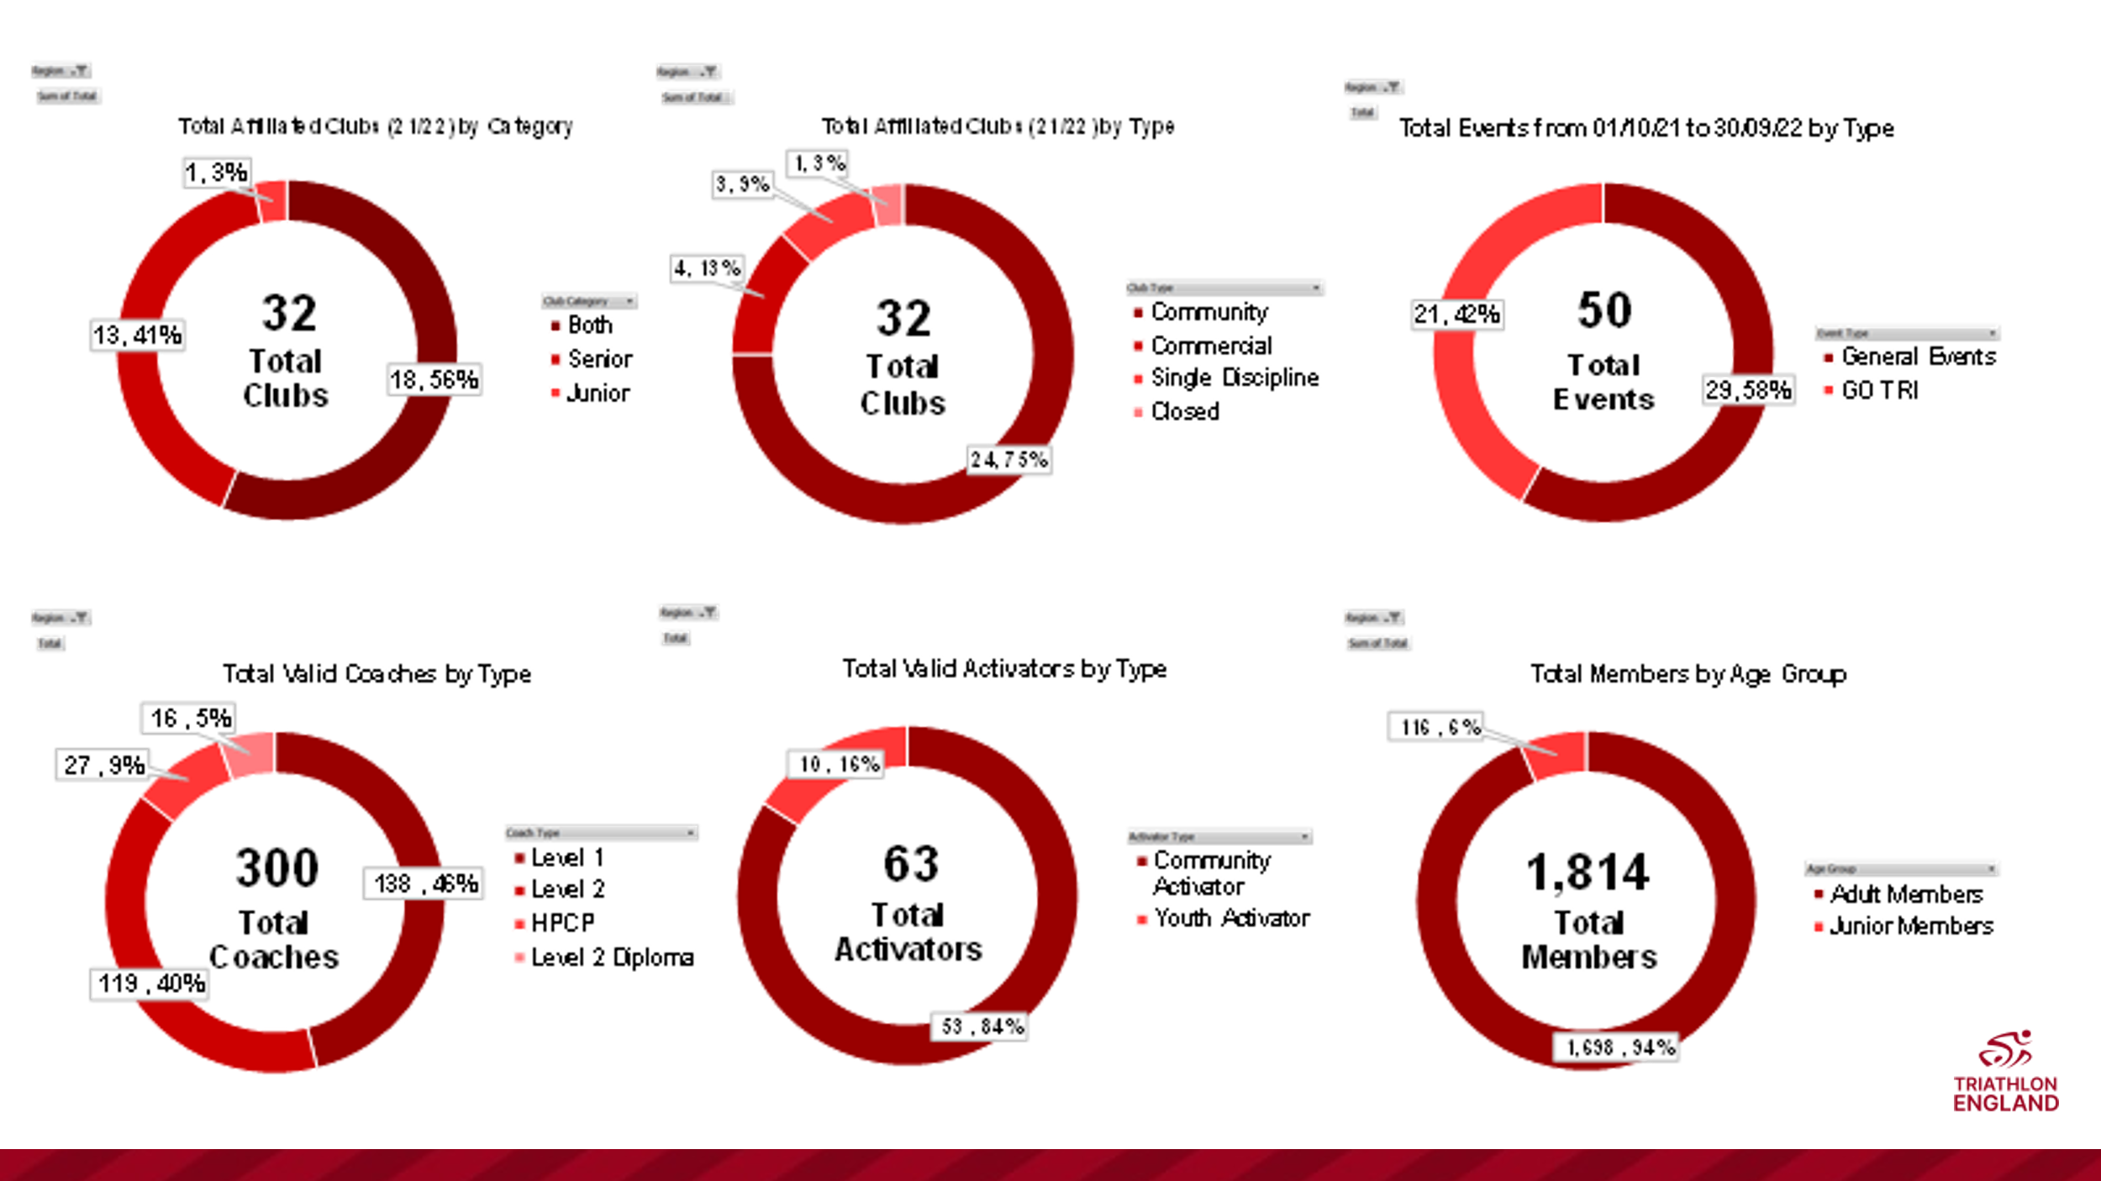

If you have any questions or queries before the AGM, please don’t hesitate to contact me either by email or phone.
kirstyouthwaite@triathlonengland.org
07739526556
Kind Regards
Kirsty Outhwaite – West Midlands Regional Manger

